# **In Lab:**

## **Lab Task 1:**

# Download the data using wget

# !wget "https://www.dropbox.com/s/veak3ugc4wj9luz/Alumni%20Giving%20Regression%20%28Edited%2 9.csv"

from keras.models import Sequential

from keras.layers import Dense, Dropout

from sklearn.metrics import classification_report, confusion_matrix

from sklearn.model_selection import train_test_split

from sklearn.metrics import mean_squared_error

import numpy as np

from sklearn import linear_model

from sklearn import preprocessing

from sklearn import tree

from sklearn.ensemble import RandomForestRegressor, GradientBoostingRegressor

import pandas as pd

import csv

import matplotlib.pyplot as plt

import seaborn as sns # Import seaborn

**Output:**

## 

## **Lab Task 2:**

np.random.seed(7)

# Read the CSV file

df = pd.read_csv("Alumni Giving Regression.csv", delimiter=",")

## **Output:**

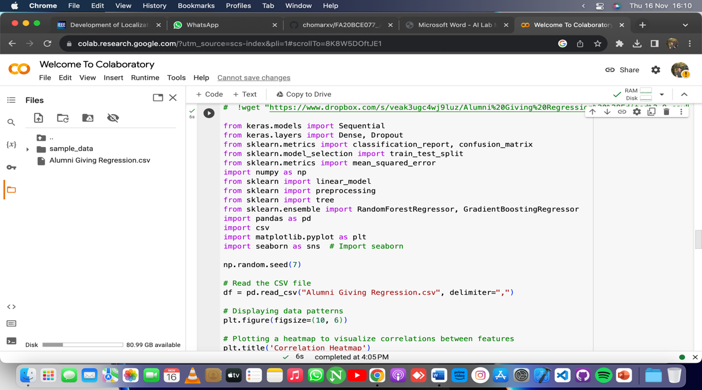

## **Lab Task 3:**

# Displaying data patterns

plt.figure(figsize=(10, 6))

# Describing the data

data_description = df.describe()

print("Data Description:\n", data_description)

## **Output:**

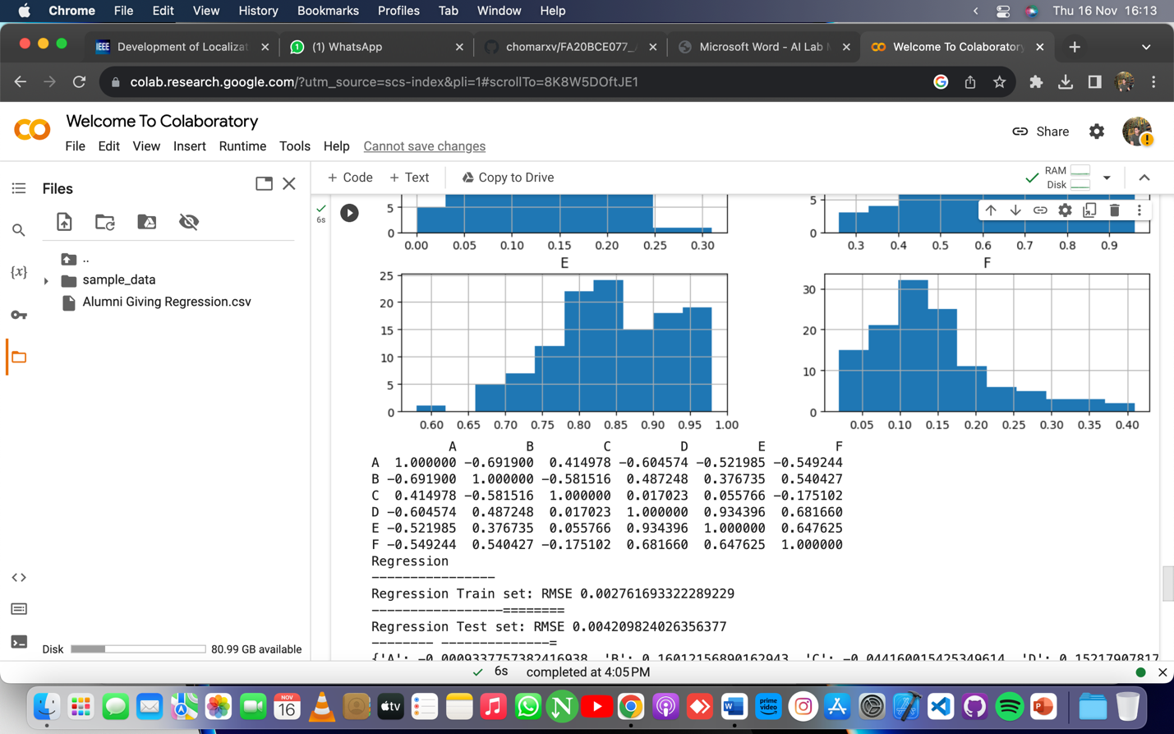

## **Lab Task 4:**

corr = df.corr(method="pearson")

print(corr)

## **Output:**

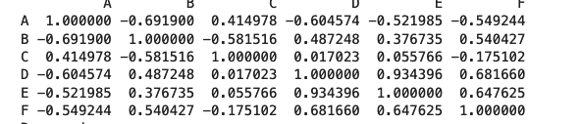

## **Lab Task 5:**

Y_POSITION = 5

model_1_features = [i for i in range(0, Y_POSITION)]

X = df.iloc[:, model_1_features]

# Correcting the syntax error in slicing for Y

Y = df.iloc[:, Y_POSITION]

X_train, X_test, y_train, y_test = train_test_split(X, Y, test_size=0.20, random_state=2020)

## **Output:**

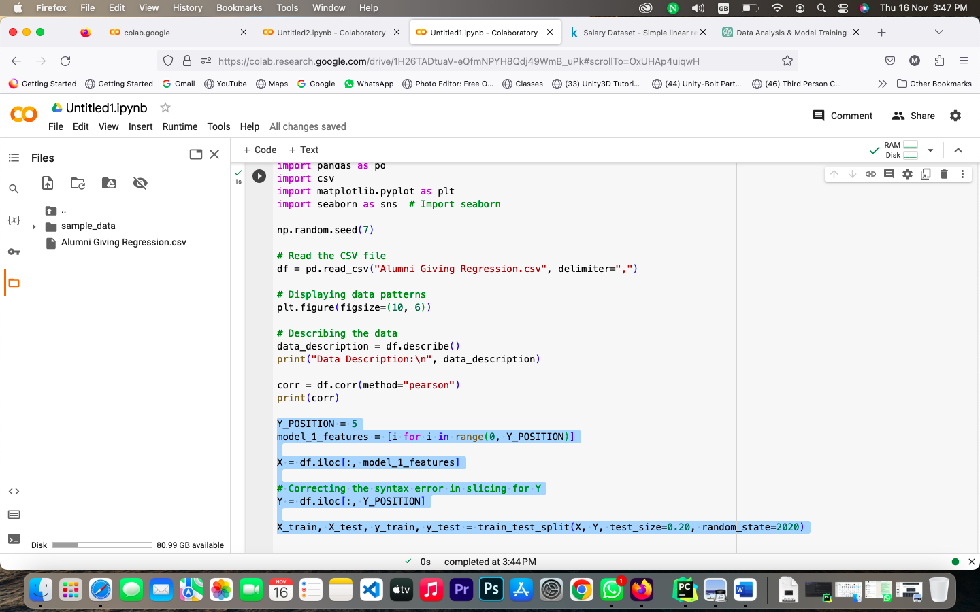

## **Lab Task 6:**

# Assuming the data has been downloaded and loaded correctly as mentioned before

model1 = linear_model.LinearRegression()

model1.fit(X_train, y_train)

y_pred_train1 = model1.predict(X_train)

print("Regression")

print("----------------")

RMSE_train1 = mean_squared_error(y_train, y_pred_train1)

print("Regression Train set: RMSE {}".format(RMSE_train1))

print("-----------------========")

y_pred1 = model1.predict(X_test) # Added missing equal sign here

RMSE_test1 = mean_squared_error(y_test, y_pred1)

print("Regression Test set: RMSE {}".format(RMSE_test1))

print("-------- --------------=")

coef_dict = {} # Corrected dictionary initialization

# Updated loop to access correct attributes of the model

for coef, feat in zip(model1.coef_, model_1_features):

coef_dict[df.columns[feat]] = coef

print(coef_dict)

## **Output:**

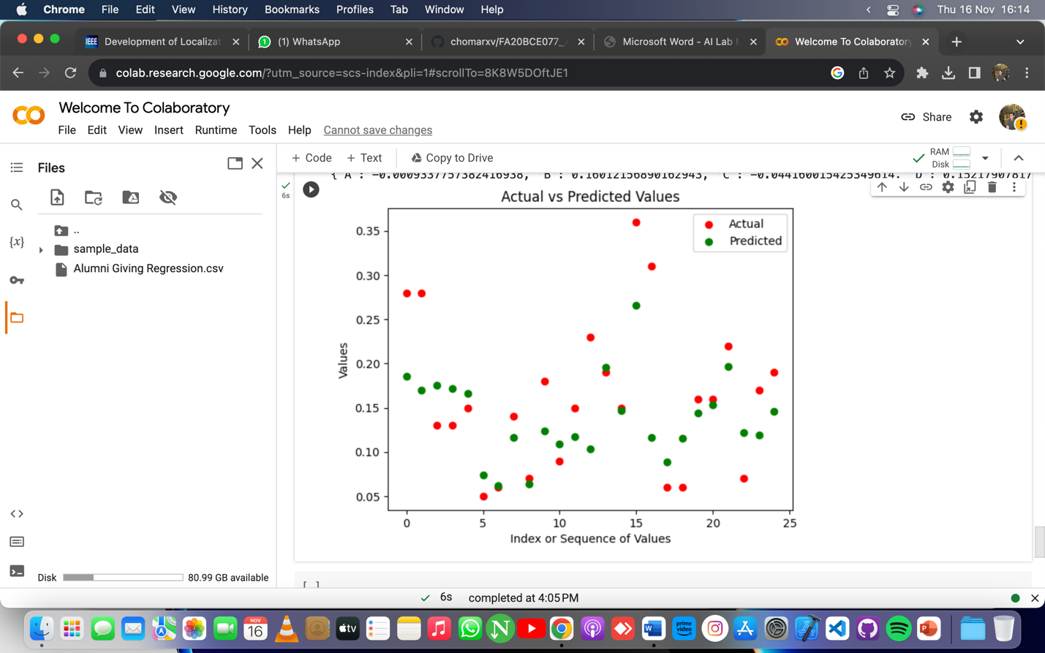

# **Post Lab:**

import pandas as pd

from sklearn.model_selection import train_test_split

from sklearn.linear_model import LinearRegression

from sklearn.metrics import mean_squared_error

from sklearn.preprocessing import PolynomialFeatures

from sklearn.model_selection import cross_val_score

# Load the dataset

data = pd.read_csv("Salary_Data.csv")

# Extracting features and target variable

X = data.iloc[:, :-1].values # Assuming the independent variable is in the first column

y = data.iloc[:, -1].values # Assuming the dependent variable (salary) is in the last column

# Splitting the data into training and test sets

X_train, X_test, y_train, y_test = train_test_split(X, y, test_size=0.2, random_state=42)

# Linear Regression

model = LinearRegression()

model.fit(X_train, y_train)

# Model Evaluation

y_pred = model.predict(X_test)

mse = mean_squared_error(y_test, y_pred)

print(f"Linear Regression Test MSE: {mse}")

# Polynomial Regression (Degree 2)

poly = PolynomialFeatures(degree=2)

X_poly = poly.fit_transform(X_train)

model_poly = LinearRegression()

model_poly.fit(X_poly, y_train)

# Model Evaluation - Polynomial Regression

X_test_poly = poly.transform(X_test)

y_pred_poly = model_poly.predict(X_test_poly)

mse_poly = mean_squared_error(y_test, y_pred_poly)

print(f"Polynomial Regression (Degree 2) Test MSE: {mse_poly}")

# Cross-validation

cross_val_scores = cross_val_score(model, X, y, cv=5, scoring='neg_mean_squared_error')

print(f"Cross-validated MSE for Linear Regression: {-cross_val_scores.mean()}")

# Cross-validation for Polynomial Regression

cross_val_scores_poly = cross_val_score(model_poly, poly.transform(X), y, cv=5, scoring='neg_mean_squared_error')

print(f"Cross-validated MSE for Polynomial Regression: {-cross_val_scores_poly.mean()}")

## **Output:**

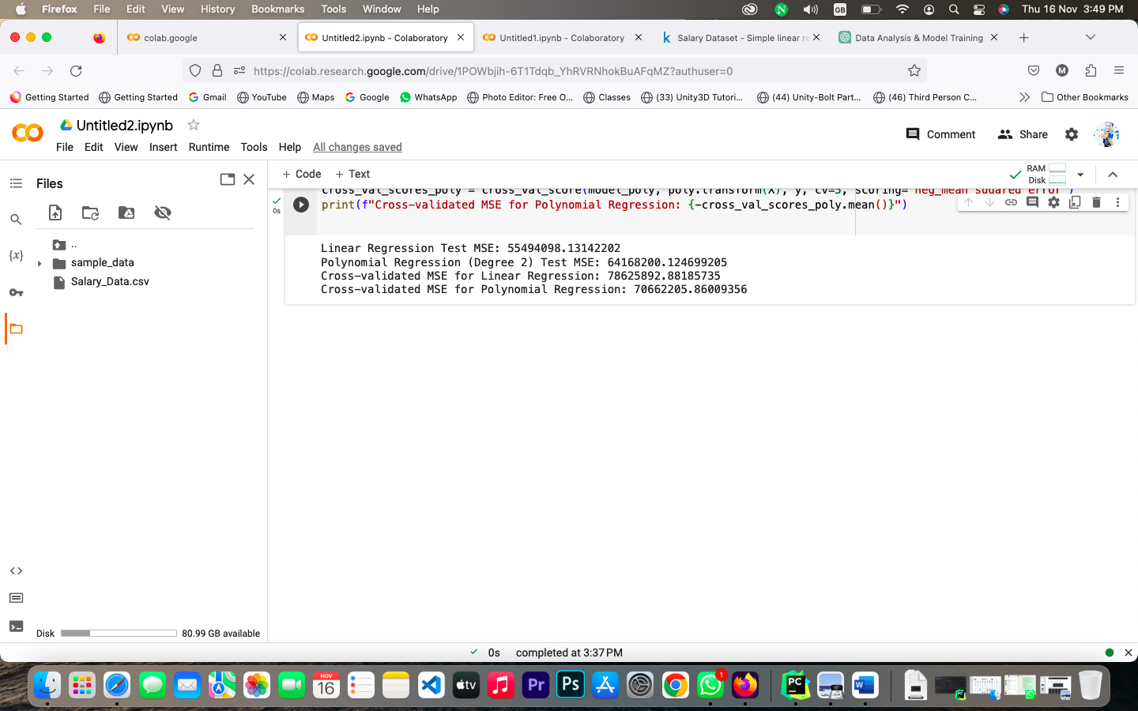

**Dataset Link:**

https://www.kaggle.com/datasets/abhishek14398/salary-dataset-simple-linear-regression/